Problem: Assume that a 3D model for the growth of a crystalline structure starts out with one small sphere. Each successive model is made by taking the next triangular number of spheres and, on both sides, filling the dents in the arrangement with spheres. Each new dent on each side will be filled to create a pyramid on each side. This will give you a shape that is like two triangular pyramids stuck together. Create a closed form and recursive formula that calculates the amount of spheres needed to build each crystalline structure.

$$n=2$$

$$n=1$$

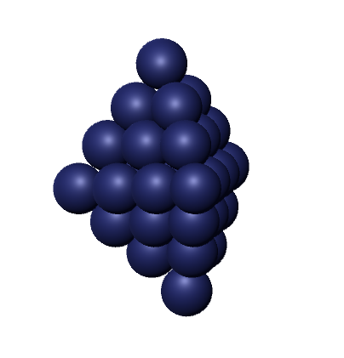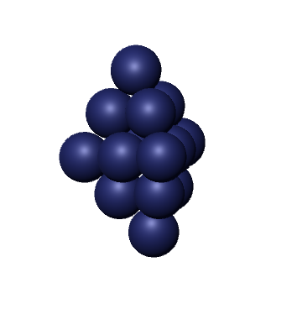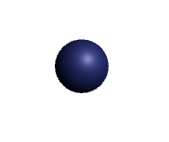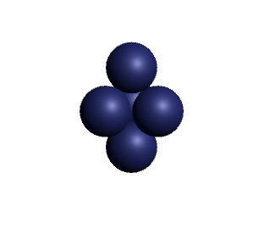

$$n=4$$

$$n=3$$

|  |  |
| --- | --- |
| n | Spheres |
| 1 | 1 |
| 2 | 5 |
| 3 | 14 |
| 4 | 30 |
| 5 | 55 |

RECURSIVE FORMULA HERE

To create the closed form expression the data from the table above is differenced, as shown below

**1**

4

**5** 5

9 2

**14** 7

16 2

**30** 9

24

**55**

The data above was differenced three times, and therefore the closed form is to the 3rd order, like so:

$$S\left(n\right)=An^{3}+Bn^{2}+Cn+D$$

Next the systems of equations must be gathered and solved.

$S\left(1\right)=1$ $S\left(3\right)=14$

$S\left(1\right)=A{\left(1\right)}^{3}+B{\left(1\right)}^{2}+C\left(1\right)+D$ $S\left(3\right)=A{\left(3\right)}^{3}+B{\left(3\right)}^{2}+C\left(3\right)+D$

$A+B+C+D=1$ $27A+9B+3C+D=14$

$S\left(2\right)=5$ $S\left(4\right)=30$

$S\left(2\right)=A{\left(2\right)}^{3}+B{\left(2\right)}^{2}+C\left(2\right)+D$ $S\left(4\right)=A{\left(4\right)}^{3}+B{\left(4\right)}^{2}+C\left(4\right)+D$

$8A+4B+2C+D=5$ $64A+16B+4C+D=30$

The four equations are then solved by using an outside resource, *Symbolab* (URL: <https://www.symbolab.com/>). The results are as follows:

$$A=\frac{1}{3}, B=\frac{1}{2}, C=\frac{1}{6}, D=0$$

This results in a final closed form equation of $S\left(n\right)=\frac{1}{3}n^{3}+\frac{1}{2}n^{2}+\frac{1}{6}n$.

**Claim: The number of spheres required to create the $n$ th crystalline structure can be computed using the formula $S\left(n\right)=\frac{1}{3}n^{3}+\frac{1}{2}n^{2}+\frac{1}{6}n$.**

Proof: The proof will be by mathematical induction on $n$.

Base step: When $n=1$ there is just one sphere, therefore the amount of spheres for the first crystalline structure is $1$. When $n=1$ the claim holds true because the formula yields $S\left(n\right)=\frac{1}{3}{\left(1\right)}^{3}+\frac{1}{2}{\left(1\right)}^{2}+\frac{1}{6}\left(1\right)=\frac{1}{3}+\frac{1}{2}+\frac{1}{6}=1.$

Induction step: Assume the claim has been proven true for $n = k$, where $k≥1$. This means the amount of spheres for the $k$ th crystalline structure is $S\left(k\right)=\frac{1}{3}k^{3}+\frac{1}{2}k^{2}+\frac{1}{6}k$.

It needs to be shown that the claim is also true for $n=k+1$.

$$S\left(k\right)=\frac{1}{3}{(k+1)}^{3}+\frac{1}{2}{(k+1)}^{2}+\frac{1}{6}(k+1)$$